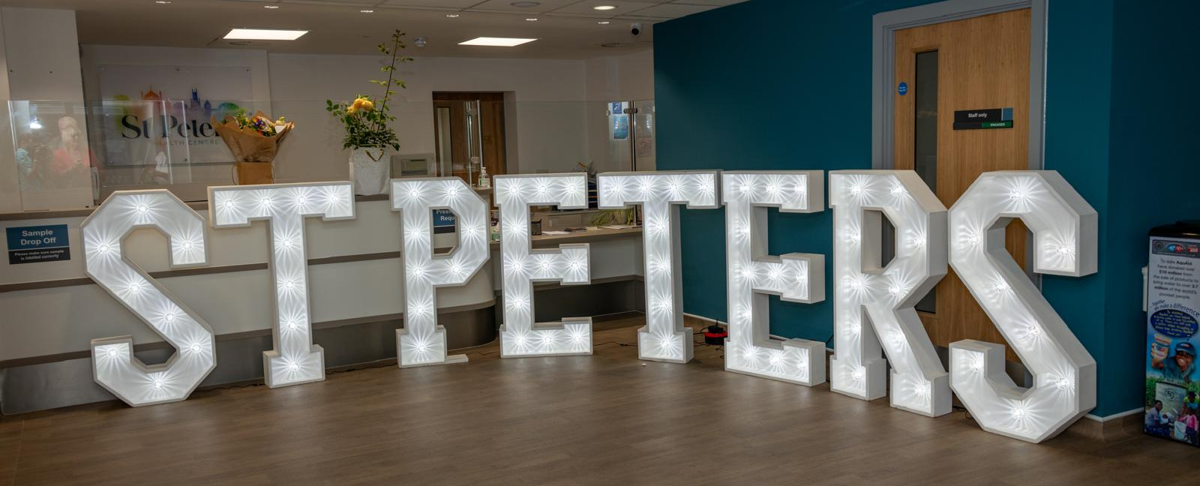
PPG Meeting Agenda
Thursday 22nd October 2026
6-7.30pm

- Welcome and introductions (Joanne)

- PPG active committee members & St Peter’s representatives
- Purpose and scope of PPG

- Agree the minutes from 23rd June meeting (Joanne)

- Matters Arising/Actions (Joanne & St Peter’s staff)

- St Peter’s List of Staff - experience & areas of interest
- PPG to keep noticeboard in surgery updated

- St Peter’s Update

- Staffing
- UOK – Mental Health Sessions
- GP/Patient Survey data – to be discussed

- PPG Update

- Healthy Hearts Event
- World Menopause Day (18th Oct) event on Tues 20th Oct
- Gloji Weightloss Group
- BNHF – walking Group around the level (funding application)
- BHCC Aging Well – fall prevention session 20th Nov (Zina Bratovic)
- HNF application for Chair Yoga
- Establishing a PPG Bank Account
- Membership of Trust for Developing Communities (TDC)
- Update from PPG Surrey and Sussex Network
- World Menopause Day (18th Oct) event on Tues 20th Oct
- Stay Safe, Stay Seen!

- Discussion

- Encouraging patient engagement in surveys and events
- Digital Access to meetings/events

- AOB

- Date of next Public Meeting – Feb 2027 tbc

