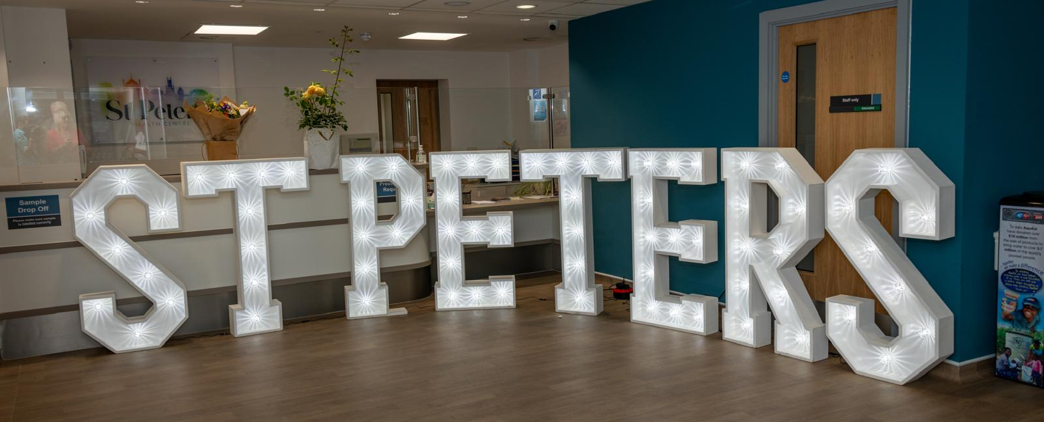
PPG Meeting Agenda
Wednesday 25th February 2026
6-7.30pm

- Welcome and introductions (Joanne)

- Agree the minutes from 24th September meeting (Joanne)

- Matters Arising/Actions (Joanne & St Peter’s staff)
  - Appointment text messaging system
  - DNA (Did Not Attend) – current options for cancelling appointment
  - Reminder - Triage system re: getting an appointment

- St Peter’s update (Dr Jarvis)

- PPG Updates (Joanne)
  - Welcome to new PPG Committee members - Michael Colett & Suzanne Hay
  - Benefits of using Robert Lodge – Phillip
  - Update from Sussex PPG Network – Joanne
    - ICB (Integrated Care Boards) to cut (50%) costs NHS Sussex and NHS Surrey Heartlands will merge
    - Healthwatch Priorities – engaging men in their healthcare, reviewing localised model of mental health care, safe guarding processes, dental provision in care homes, strengthening voices of young people in healthcare
    - New PPG grant scheme – can apply for up to £1000 – application deadline 16th March
    - Ongoing PPG Activities – DNA /Appointment Systems/PPG surveys
    - NHS Sussex – ‘Know Your Numbers’ blood pressure campaign
  - World Menopause Day/Cafes – Joanne
  - Health Awareness Events– e.g. Pharmacy First, Healthy Heart Day

- Discussion Focus:
- Health Education
- Widening Community Engagement

- AOB (Joanne)
  - Date of next Public Meeting – Wed 3rd June (tbc)?

