Summary of the key cold weather and fuel poverty initiatives in Brighton & Hove 2022-23
The latest available figures released in May 2022, estimate that in 2020, 12% of households in Brighton & Hove were in fuel poverty. This equates to 15,814 households in the city.

With the cost of living and fuel prices increasing ther are likely to be many more people in cold homes this winter.

Although the definition of fuel poverty does not take account of energy costs directly, it can be assumed that the number of households in the city struggling to pay their energy bills has increased significantly over recent months due to the significant increases in energy tariffs and the general costs of living.

Living in a cold home as a result of fuel poverty has a disproportionate impact on the health of certain groups. Exposure to cold temperatures increases blood pressure and risk of blood clotting, heart failure/attack and stroke. It also suppresses the immune system, diminishes the lungs’ capacity to fight off infection and increases constriction of the airways, increasing the risk of bronchitis and pneumonia. When a house is damp as well as cold, mould is likely to occur. This increases the risk of respiratory illness, particularly asthma.
The Department of Health and Social Care research found that negative health effects start at relatively moderate outdoor temperatures of around 4-8°C.
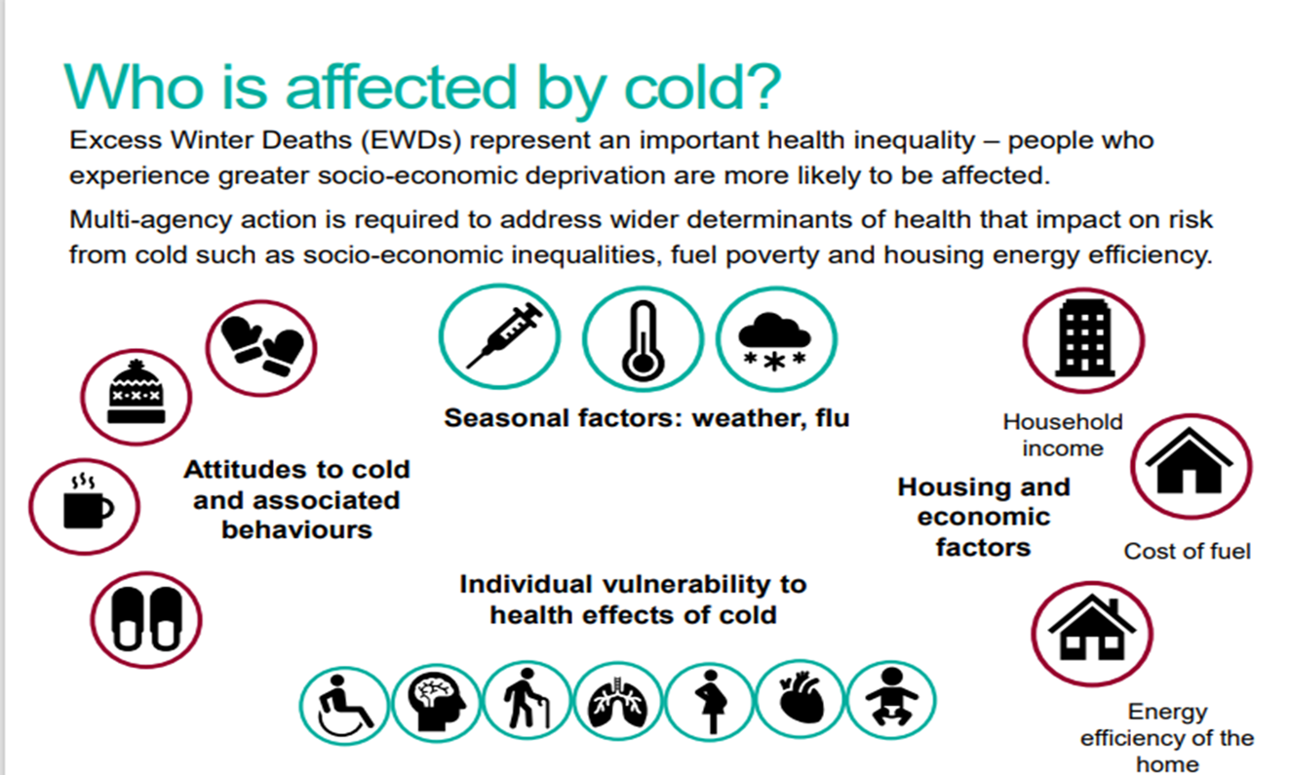
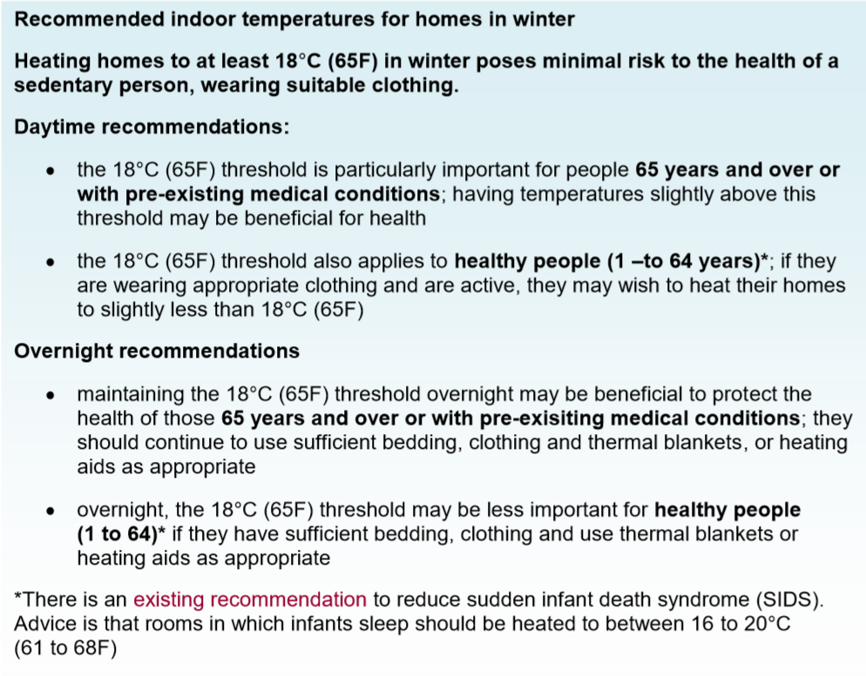
Service that can help

Energyworks

Money Advice Plus, Citizens Advice Brighton and Hove, and their energy partners are pleased to be offering help with fuel bills and keeping homes warm. They provide money advice and casework, including support with benefits, debt, budgeting, switching, and other help to keep homes warm. They can also provide grants for fuel bill payments and onwards referrals to relevant partners. Please bear in mind this service has limited capacity and a current waiting list. Please only refer people who are vulnerable and/or in significant need of this service.

Contact:
Email energyworks@cabrightonhove.org to request a referral form. Clients can also self-refer using this email address.
Clients can also self-refer by calling 0333 090 9150 – this is a voicemail only line for clients without internet access to call and leave their details.

BHESCo (Brighton & Hove Energy Services Co-operative)

Free home visits to qualifying households, offering energy advice, help with energy companies, and installation of energy saving kit (e.g. lightbulbs, draught-proofing, radiator reflectors). In emergency situations, they can also provide items such as portable heaters, thermal curtains and electric blankets.

For more information, go to: https://bhesco.co.uk/blog/energy-bill-crisis-what-help-is-available-sussex

Contact:
Email: info@bhesco.co.uk with the subject heading: Energy Advice
Call: 0800 999 6671 or 01273 284470

LEAP (Local Energy Advice Partnership)
Free phone call or home visit providing support with energy bills, advice on saving energy and heating systems and installation of simple energy saving measures. LEAP can also arrange a free telephone advice service to help with benefits, debt and other money problems, as well as referrals for further energy efficiency improvements, such as insulation and efficient heating systems.

Contact: To book a free energy advice phone call or home visit call free on 0800 060 7567 or apply online: www.applyforleap.org.uk

The council’s website is being updated with advice on available energy support (Help with fuel bills (brighton-hove.gov.uk)

Food initiatives

Impact Initiatives continues with their Food Access service, supporting elderly and housebound residents to access food. They also deliver an ‘on the day’ emergency voucher or parcel if they cannot refer to another food bank that day. East Brighton Food Co-op city-wide meal delivery service and takes referrals for housebound residents who cannot afford to pay for food, but need a meal delivered.
Contact: food.access@impact-initiatives.org.uk or ring 01273 322950
The Emergency Food Network report from July 22 identified 44 food banks, social supermarkets and meal projects working out of 50 locations in the city.
Contact: https://bhfood.org.uk/category/get-involved/referrals/ or ring 01273 234810

Cold Weather advice and alerts

The Cold Weather Alert operates in England from the 1 November to 31 March every year and come from the Met office and UKHSA. These set out the level of alert based on the predicted and actual temperature, snow etc and link to the actions organisations should take to protect those at most risk for the negative effects of the cold. Organisations can subscribe to this for free.

The NHS and Council cascade these alerts to the practices, services and the community.

Please find the full set of Action Cards here and these are updated nationally https://www.gov.uk/government/publications/cold-weather-plan-action-cards-for-cold-weather-alert-service

The action cards list required actions to be taken for each level of the cold weather alerts and include actions cards for
- commissioners and local authorities
- provider organisations
- frontline health and social care staff
- GPs and practice staff
- individuals
- voluntary and community sector

Please see general information leaflets:
- Keep warm Keep well leaflet ‘Keep Warm Keep Well’ leaflet - GOV.UK (www.gov.uk)
- Top Tips for keeping warm and well Top tips for keeping warm and well 2021 (publishing.service.gov.uk)
- Stay well this winter We're here to help you stay well this winter (assets.nhs.uk)
- How to stay well this winter How to stay well in winter - NHS (www.nhs.uk)
- Stay Well This Winter | Campaign Resource Centre (phe.gov.uk) has a selection of printable material, also available;
- stay well this winter: large print version (PDF, 1.8Mb)
- stay well this winter: audio file on Soundcloud
- stay well this winter: British Sign Language (BSL) video on Youtube
- stay well this winter: easy read version (PDF, 1.2Mb)

Key public health messages

Take up your Covid-19 vaccination when it is offered/available

Contact your GP or pharmacist if you think you, or someone you care for, might qualify for a free Flu jab.

Free Flu vaccinations are available for those who are at risk. For a full list see the annual Flu plan, available at: www.gov.uk/government/collections/annual-flu-programme

Keep your home warm, efficiently and safely:
- heating your home to at least 18°C in winter poses minimal risk to your health when you are wearing suitable clothing
- get your heating system and cooking appliances checked and keep your home well ventilated
- use your electric blanket as instructed and get it tested every 3 years
- never use a hot water bottle with an electric blanket
- do not use a gas cooker or oven to heat your home; it is inefficient and there is a risk of carbon monoxide poisoning and this can kill
- make sure you have a supply of heating oil or LPG or sold fuel if you are not on mains gas or electricity – to make sure you do not run out in winter

Keep in the warmth by:
- fitting draught proofing to seal any gaps around windows and doors
- making sure you have loft insulation. And if you have cavity walls, make sure they are insulated too
- insulate your hot water cylinder and pipes
- draw your curtains at dusk to help keep heat generated inside your rooms
- make sure your radiators are not obstructed by furniture or curtains

Look after yourself:
- food is a vital source of energy and helps to keep your body warm so have plenty of hot food and drinks
- aim to include 5 daily portions of fruit and vegetables. Tinned and frozen vegetables count toward your 5 a day
- stock up on tinned and frozen foods so you don’t have to go out too much when it’s cold or icy
- exercise is good for you all year round and it can keep you warm in winter
- if possible, try to move around at least once an hour. But remember to speak to your GP before starting any exercise plans
- wear lots of thin layers – clothes made from cotton, wool or fleecy fibres are particularly good and maintain body heat
- wear good-fitting slippers with a good grip indoors and shoes with a good grip outside to prevent trips, slips and falls
- make sure you have spare medication in case you are unable to go out
- check if you are eligible for inclusion on the priority services register operated by your water and power supplier

Look after others:
- check on older neighbours or relatives, especially those living alone or who have serious illnesses to make sure they are safe, warm and well

Get financial support:
there are grants, benefits and sources of advice to make your home more energy efficient, improve your heating or help with bills. It’s worthwhile claiming all the benefits you are entitled to before winter sets in.

